The Fundamentals - Setting Up our Database Filemaker Pro 4.0

When you finish this training on the fundamentals, you will have created a database solution consisting of four relational databases all working together to create a
Invoice, Line Item, Product &Customer database.

You will learn relationships, look-ups, calculations, scripting, drop-down lists, summary fields, summary reports, portals, file sharing, networking and more.

1. First we'll create a database. A database is a file. Within your new file you will have individual records that each contain different fields for storing different information.
like- first name, last name, address etc.

2. Start Filemaker Pro 4, do not open or create a file yet and lets go to
edit / preferences / application and check "add newly defined fields to current layout."
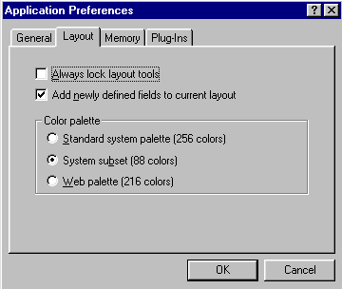

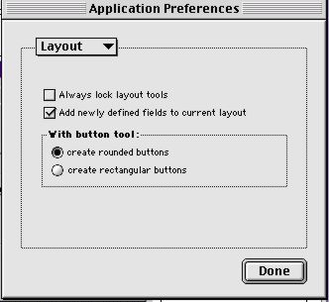

Filemaker Pro 5 Window

Filemaker Pro 4 Window

3. Now select New database from the file menu. Lets call it "Customers.fp5"

Do not worry about adding the .fp5 extension if your on a PC, Filemaker will do it for you, if your on mac, add the .fp5 extension this will ensure cross platform (mac/pc) compatibility.

If we are using Filemaker Pro 4 the extension would be .fp4 (for training we will use .fp5)

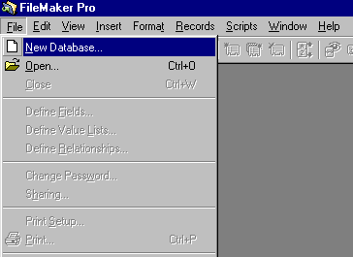


Having difficulty?
please ask for help
at anytime
during this session…
After saving your filename "customers.fp5" you will see the field definitions window below

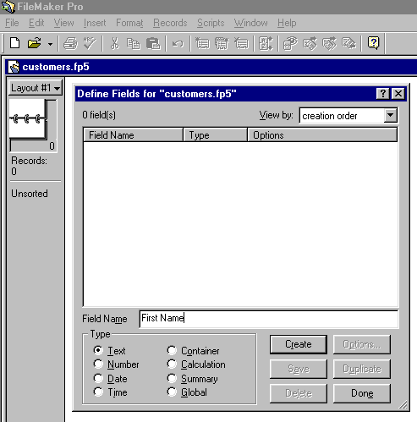

. Lets create all the fields we will

4. Create all the files we will need now.
Type in "First Name" leave the radio button below it set to "Text" and click on create.
Now repeat the process for "Last Name", "Address", "City", "State", "Zip code", "Phone", "Custnumber". All these should be Text fields.

5. Lets create a Date field and call it "Customer Since"
6. Finally a Calculation field called "Current Date"

When you click on create for the "Current date" calculation field, you will see the new
window below for entering what the calculation should be in the upper right of this window

7. Where it says "view-all by name" change to status functions.

You now see a different set of functions. These are status functions.

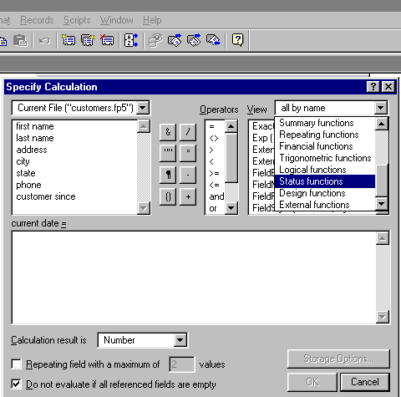

8. We want to double click Status (CurrentDate)

After double clicking on Status (Current Date) you will notice this places it into your calculation.
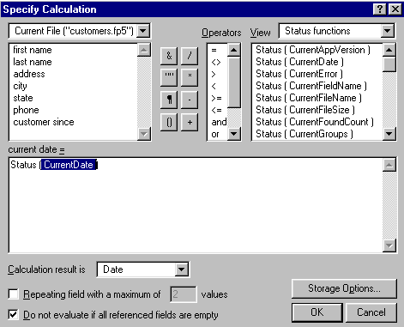

Below this white calculation area is a drop down list that says calculation result is Number

9. Change this to Date.
10. Click on the Storage Options button then check the
√  "Do not store calculation results--calculate only when needed"
This will mean it will update itself every time the record is viewed.

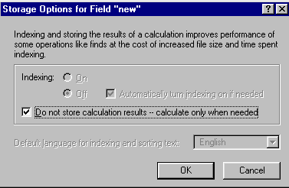

11. Click OK

12. And click on OK at the bottom of this window.

You have just created a calculation to give you the current date whenever you view this record.

We now need a unique field for
custnumber field
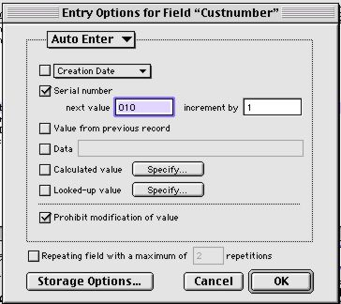
13. From the File menu open
Define Fields and click on field
Custnumber

14. Click on the Options button
This will take us to this Window

15. Click Serial Number and set
The number to 001

16. Click Prohibit modification
of value

17. Click OK

18. Now let's create one last field "length as a customer" a calculation field.

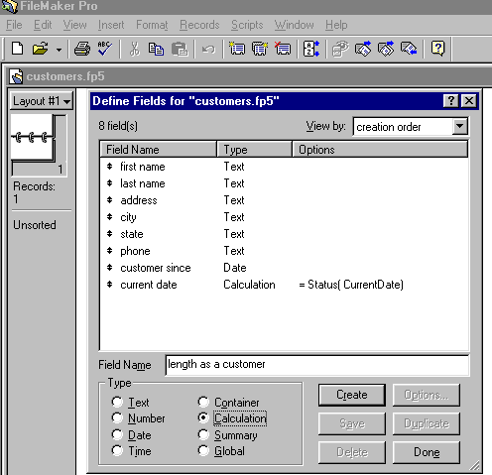

We are going to calculate how long each client has been a member (in days).

19. Again you will be presented with the calculation window.

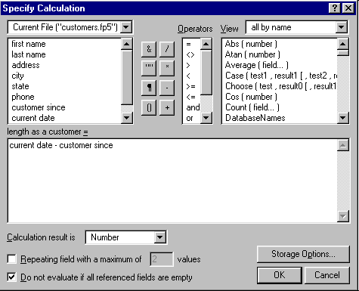

20. Lets double click on the field "current date" from the upper left sub-window and you see it placed in the calculation area.

21. Now lets click on the minus "-" button in the center of your window.

22. Then finally double click on "customer since" field and now after that places it in the calculation area you should see...

current date - customer since
We want to make the calculation result a number
(Calculation result is Number).

23. Then click "OK" You have now created a calculation to return the number of days
each customer has been our customer.

24. Then click "Done"

Sharing Databases (Networking)
Did you know your file can be shared by many people at one time, also can be shared
by Mac's and Pc's at the same time, this means it is what we call cross-platform.

But we need to set it to Multi-user if we want to share it.

25. Let's do it go to File / Sharing
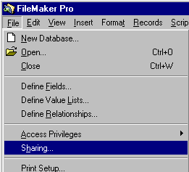

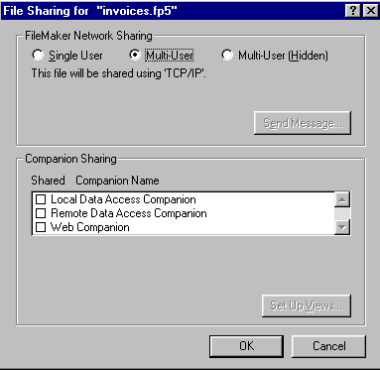

26. Click on Multi-User

One more thing though, we need to set up our application for networking.
We have to set the network protocol we'll be using in the application preferences.

27. So go to Edit / Preferences / Application

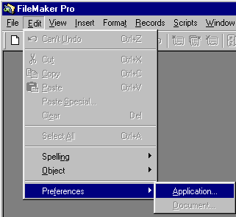

We'll select TCP/IP for our purposes
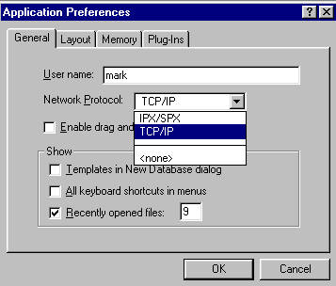

28. Click OK.

You will need to restart
Filemaker to set this do it.

29. Now open the database again
you should get the message it
is opening as a multi-user file.

NOTE: For training we will revert
To Single User

BUT WAIT THERE'S MORE!

One final thing….

Let us change the layout name from Layout#1 to Customers

30. Go to Mode menu

31. and to Layout Setup…

32. Replace Layout#1 with Customers in the Layout Name box

33. Ensure Include in layouts menu is ticked

34. Click OK

This ends this session

Prepared by Peter J Faulks
14/4/00 11:41:11 AM

